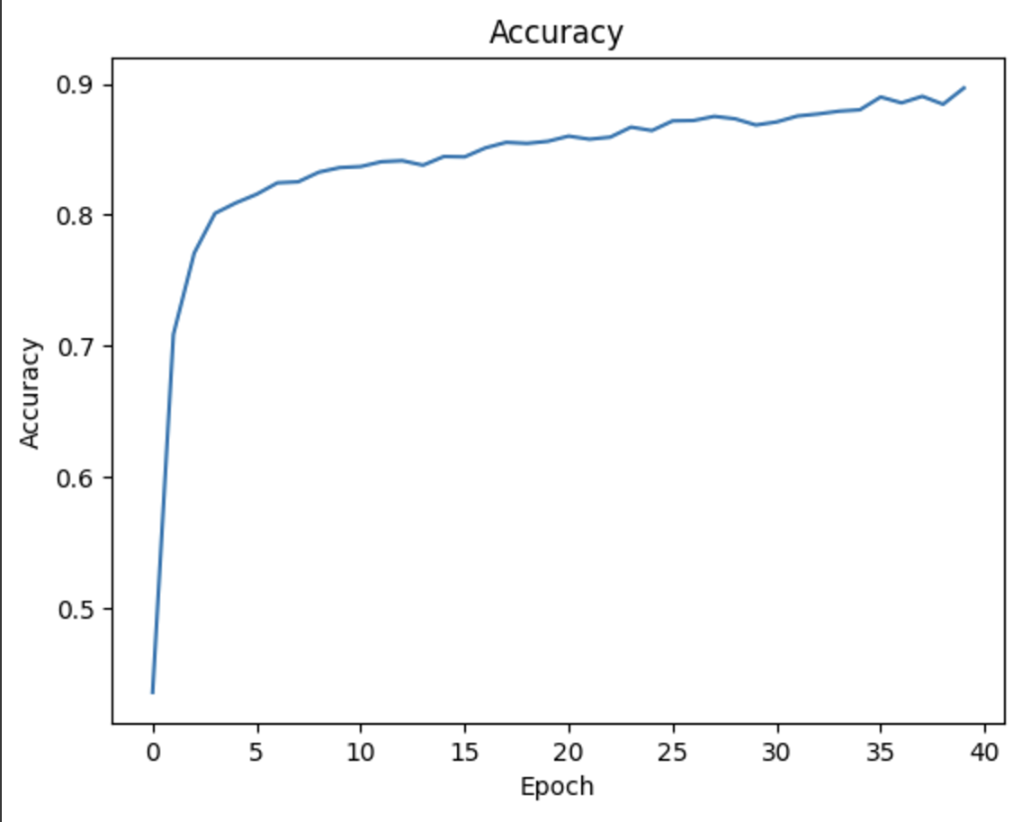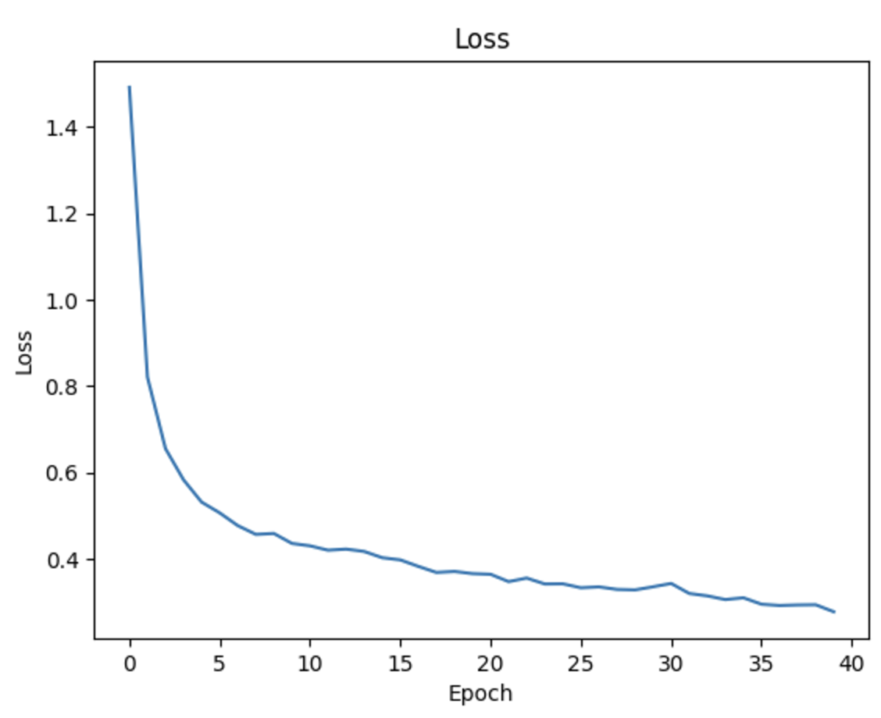

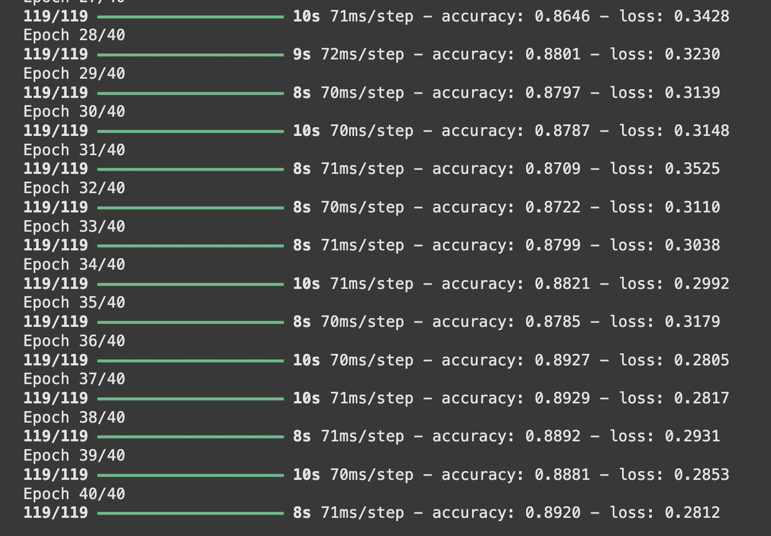

21/21 ━━━━━━━━━━━━━━━━━━━━ 2s 51ms/step - accuracy: 0.5818 - loss: 2.0471

Loss = 1.9991554021835327

Test Accuracy = 0.5878693461418152

